South China University of Technology
《Course》Experiment Report
Experiment Title： The Design an Analysis of Computer Algorithms
Name： 张杰铖 Student ID： 202030443394
Class： 计科全英联合班 Group： Individual
Collaborator： NO
Teacher： 颜小洋
Description
【Objective and Requirement】
Objective：
Learn how to solve the minimum spanning tree problem using the greedy algorithm. Implement Peim's algorithm.
Requirement：
Solve Minimum Spanning Tree (MST) Problem by Greedy Algorithms
【Environment】
Operating System：Windows 10
Content
【Procedure】
- Step：
- Build a basic MST test chart.
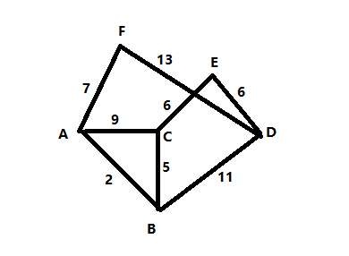
- There are two algorithms to solve the minimum spanning tree problem using greedy algorithm - Peim's algorithm and Kruskal's algorithm, we choose Peim's algorithm. First implement the Linked-List data structure, and then implement the Linked-List-based graph data structure. Finally, the Peim algorithm is completed. Apply the algorithm to the constructed test graph.
2. Program：
#include <iostream>
using namespace std;
#define NOTPATH 999999

template <class Elem> class listNode{
public:
Elem element;
listNode* next;
listNode(Elem& e,listNode* n=NULL){
element=e;
next=n;
}
listNode(listNode* n=NULL){
next=n;
}
};

template <class Elem> class Linked_list{
public:
listNode<Elem>* head;
listNode<Elem>* tail;
listNode<Elem>* fence;
int rightcnt,leftcnt;
Linked_list(){
head=tail=fence=NULL;
rightcnt=leftcnt=0;
}
void clear(){
while(head!=tail) {
fence=head;
head = head->next;
delete fence;
}
rightcnt=leftcnt=0;
}
bool insert(Elem& e){
fence->next=new listNode<Elem>(e,fence->next);
if (fence==tail){
tail=fence->next;
}
rightcnt++;
return true;
}
bool append(Elem& e){
tail->next=new listNode<Elem>(e,tail->next);
tail=tail->next;
rightcnt++;
return true;
}
bool remove(Elem& it){
if(fence==tail){return false;}
listNode<Elem>* temp=fence->next;
fence->next=fence->next->next;
it=temp->element;
delete temp;
rightcnt--;
return true;
}
void setStart(){
fence=head;
rightcnt=leftcnt+rightcnt;
}
void setEnd(){
fence=tail;
leftcnt=leftcnt+rightcnt;
}
void prev(){
if(fence==head){return;}
listNode<Elem>* temp=head;
while(temp->next!=fence){
temp=temp->next;
}
fence=temp;
leftcnt--;
rightcnt++;
}
void next(){
if (fence==tail){return;}
fence= fence->next;
leftcnt++;
rightcnt--;
}
int leftLength(){
//左边的匣子数
return leftcnt;
}
int rightLength(){
return rightcnt;
}
bool setPos(int pos){
if(rightcnt+leftcnt<=pos){return false;}
fence=head;
rightcnt=leftcnt+rightcnt;
leftcnt=0;
while(pos--){
fence=fence->next;
leftcnt++;
rightcnt--;
}
return true;
}
bool getValue(Elem& it){
if(fence==tail){return false;}
it=fence->next->element;
return true;
}
void print(){
listNode<Elem>* temp=head;
cout<<"< ";
while(temp!=fence){
cout<<temp->next->element<<" ";
}
cout<<"| ";
while(temp!=tail){
cout<<temp->next->element<<" ";
}
cout<<">"<<endl;
}
};

class Graph{
public:
Linked_list<int>** graph;
int n;
int e;
int** Weight;
bool* Mark;

Graph(int tempn=10){
n=tempn;
e =0;
graph=new Linked_list<int>*[n];
for(int i=0;i<n;i++){
graph[i]=new Linked_list<int>();
}
Weight=new int*[n];
for(int i=0;i<n;i++){
Weight[i]=new int[n];
for(int k=0;k<n;k++){
if(i==k){Weight[i][k]=0;}
else{Weight[i][k]=NOTPATH;}
}
}
Mark=new bool[n];
for(int i=0;i<n;i++){
Mark[i]= false;
}
}
~Graph(){
delete Weight;
delete Mark;
delete graph;
}
int getn(){return n;}
int gete(){return e;}
int first(int a){
if(graph[a]->head==graph[a]->tail){return getn();}
graph[a]->setPos(0);
int result;
graph[a]->getValue(result);
return result;
}
int next(int a,int b){
graph[a]->setPos(0);
while(graph[a]->fence!=graph[a]->tail&&graph[a]->fence->next->element!=b) {
graph[a]->next();
}
if(graph[a]->fence==graph[a]->tail){return getn();}
graph[a]->next();
int result;
graph[a]->getValue(result);
return result;
}
void setEdge(int ver1,int ver2,int wei){
if(Weight[ver1][ver2]==NOTPATH){
graph[ver1]->append(ver2);
}
Weight[ver1][ver2]=wei;
e++;
//有向图和无向图
if(Weight[ver2][ver1]==NOTPATH){
graph[ver2]->append(ver1);
}
Weight[ver2][ver1]=wei;
//n++;
}
bool delEdge(int ver1,int ver2){
if(Weight[ver1][ver2]==NOTPATH){return false;}
graph[ver1]->setPos(0);
while (graph[ver1]->fence!=graph[ver1]->tail&&graph[ver1]->fence->next->element!=ver2){

}
if(graph[ver1]->fence->next==graph[ver1]->tail){return false;}
graph[ver1]->remove(ver2);
Weight[ver1][ver2]=NOTPATH;
e--;
//有向图和无向图
if(Weight[ver2][ver1]==NOTPATH){return false;}
graph[ver2]->setPos(0);
while (graph[ver2]->fence!=graph[ver2]->tail&&graph[ver2]->fence->next->element!=ver1){

}
if(graph[ver2]->fence->next==graph[ver2]->tail){return false;}
graph[ver2]->remove(ver1);
Weight[ver2][ver1]=NOTPATH;
//n--;
return true;
}
int weight(int ver1,int ver2){
return Weight[ver1][ver2];
}
bool getMark(int ver){return Mark[ver];}
void setMark(int ver,bool flag=true){
Mark[ver]=flag;
}
};

//最小生成树
//Peim's Alogorithm
void AddEdgetoMST(int ver1,int ver2){
cout<<"Add Edge to MST "<<ver1<<" "<<ver2<<endl;
//一些action表示这条边被加进最小生成树了
}
void Peim(Graph* g,int* D,int start){
g->setMark(start,true);
int V[g->getn()];
for(int i=0;i<g->getn()-1;i++){
int ver= minVertex_Linear(g,D);
g->setMark(ver, true);
if(D[ver]==NOTPATH){return;}
if(ver!=start){ AddEdgetoMST(V[ver],ver);}
for(int w=g->first(ver);w<g->getn();w=g->next(ver,w)){
if(D[w]>g->weight(ver,w)){
D[w]=g->weight(ver,w);
V[w]=ver;
}
}
}
}

int main() {

Graph* g=new Graph(6);

g->setEdge(0,5,7); //AF 7
g->setEdge(0,1,2); //AB 2
g->setEdge(0,2,9); //AC 9
g->setEdge(1,2,5); //BC 5
g->setEdge(1,3,11); //BD 11
g->setEdge(2,4,6); //CE 6
g->setEdge(3,4,6); //DE 6
g->setEdge(4,5,13); //EF 13
//起始点A
int d[6]={NOTPATH,2,9,NOTPATH,NOTPATH,7};
Peim(g,d,0);

}
3. Result：
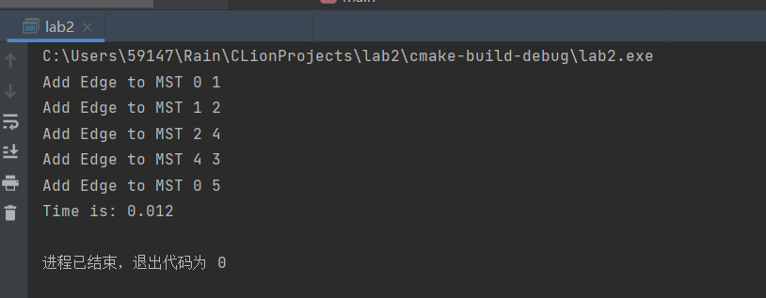
Conclusion
Learned how to implement Peim's algorithm. Recognizing that it is feasible to solve the minimum spanning tree problem by the greedy method, the efficiency of Peim's algorithm is excellent.
Teacher’s Comments and Score
Comment：

Score： Signature：
Date：

